EXNO:4 Implement programs to check stationary of a time series data

Date:20.02.25

AIM:

Write a code in python and Implement programs to check stationary of a time series data.

PROCEDURE AND CODE:

Step1:

import numpy as np

import pandas as pd

import matplotlib.pyplot as plt

import statsmodels.api as sm

from statsmodels.tsa.stattools import adfuller

Step2:

# Generate synthetic time series data with random noise

np.random.seed(42)

time = np.arange(1, 11)

values = np.array([10, 15, 8, 12, 14, 10, 9, 11, 13, 7]) + np.random.normal(0, 1,

len(time))

Step3:

# Create DataFrame

df = pd.DataFrame({'Time': time, 'Value': values})

# Plot the time series data

plt.figure(figsize=(6,4))

plt.plot(df['Time'], df['Value'], marker='o', linestyle='-', color='b', label="Time Series Data")

plt.xlabel('Time')

plt.ylabel('Value')

plt.title('Modified Time Series Data')

plt.legend()  
plt.show()

Step4:

# Perform Augmented Dickey-Fuller test

def adf_test(series):

result = adfuller(series)

print(f'ADF Statistic: {result[0]}')

print(f'p-value: {result[1]}')

print('Critical Values:')

for key, value in result[4].items():

print(f' {key}: {value}')

if result[1] <= 0.05:

print("The data is stationary (reject the null hypothesis).")

else:

print("The data is non-stationary (fail to reject the null hypothesis).")

Step5:

# Apply ADF test

adf_test(df['Value'])

# Calculate rolling mean and standard deviation

df['Rolling_Mean'] = df['Value'].rolling(window=3).mean()

df['Rolling_Std'] = df['Value'].rolling(window=3).std()

# Plot rolling statistics

plt.figure(figsize=(6,4))

plt.plot(df['Time'], df['Value'], marker='o', linestyle='-', color='b', label="Original Data")

plt.plot(df['Time'], df['Rolling_Mean'], marker='s', linestyle='--', color='r', label="Rolling Mean (Window=3)")

plt.plot(df['Time'], df['Rolling_Std'], marker='^', linestyle='-.', color='g', label="Rolling Std (Window=3)")

plt.xlabel('Time')

plt.ylabel('Value')

plt.title('Rolling Mean & Standard Deviation')

plt.legend()

plt.show()

OUTPUTS:  
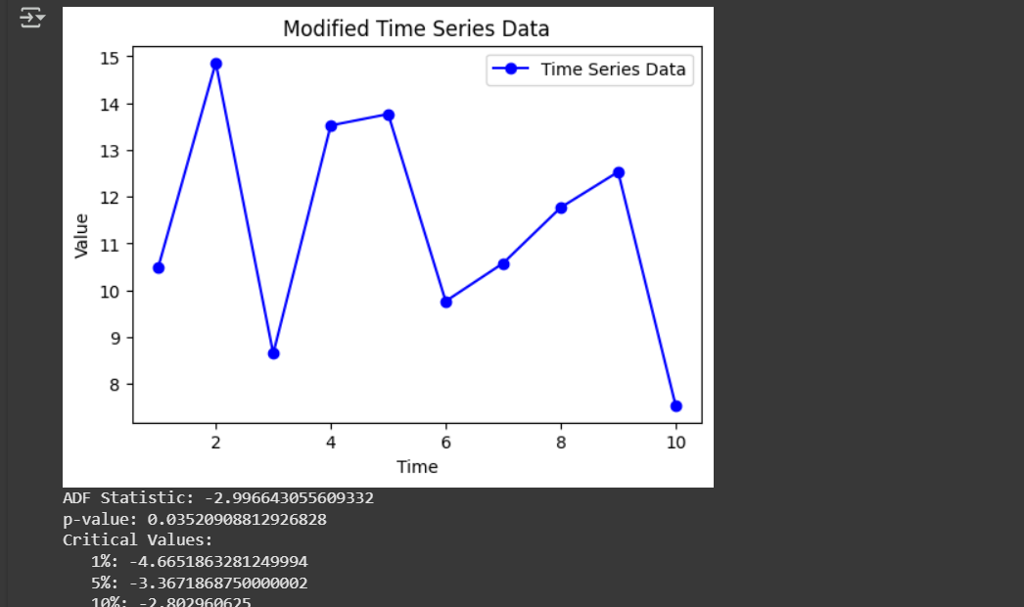

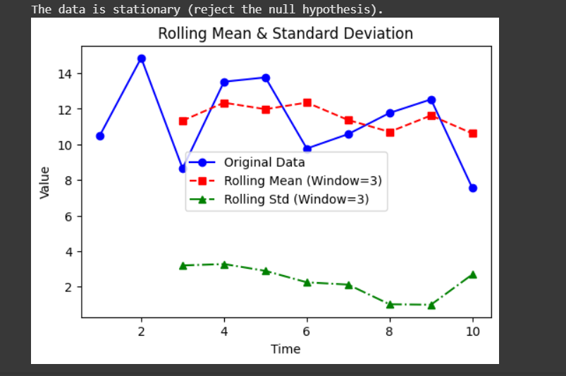

RESULT:  
 Thus the program has been executed successfully